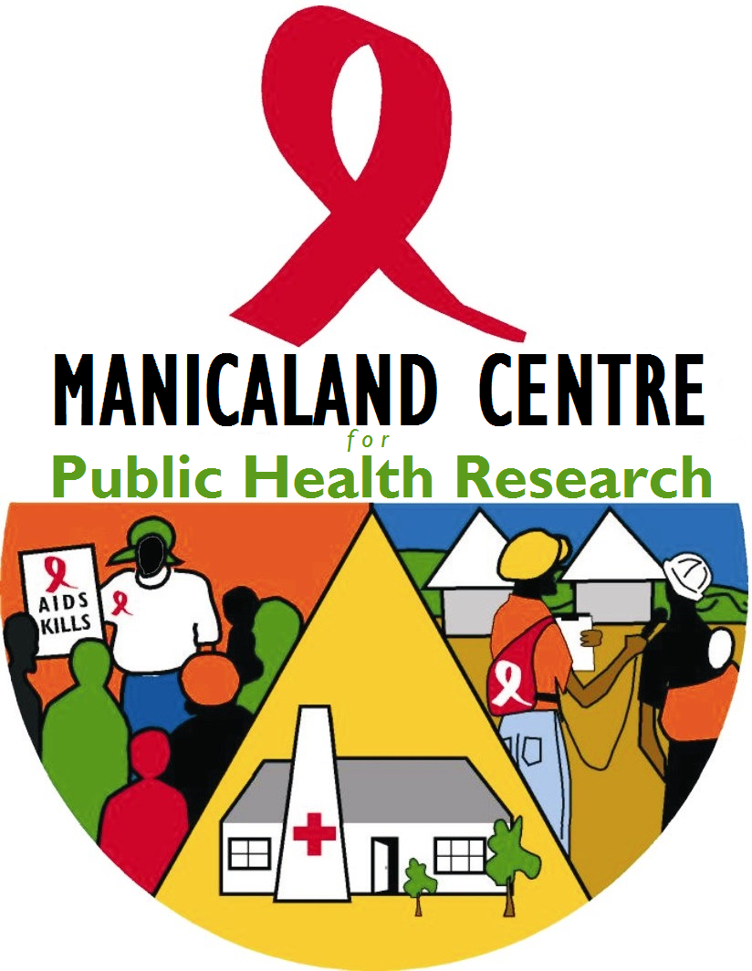
HIV M&E Health Facility Survey Report 2015

Prof. S.K. Chandiwana Public Health Research Centre, Mutasa D.C., PO Box 3449, Hauna.
Biomedical Research & Training Institute, 10 Seagrave Rd, Avondale, PO Box CY 1753, Harare.
Tel: 04 333091/335641

Introduction

Zimbabwe is expanding access to HIV prevention, care and treatment services in line with the national HIV and AIDS strategic plans. This necessitates systematic surveillance on the availability and provision of services to provide evidence for improving programme management. The Manicaland Centre measures trends in uptake and effectiveness of services in a population-based cohort survey in 12 locations in east Zimbabwe. Results are published in local epidemic progress reports and scientific publications.

To assess how these trends in uptake and effectiveness reflect changes in local availability of HIV and AIDS services, the Manicaland M&E Facilities Study, a parallel survey of the Main Study is conducted for local health facilities. This study measures trends in district-level provision of national HIV and AIDS programme activities for Mutasa and Makoni districts.

The following report examines local patterns of facility-level services, such as ART, HIV testing and counselling, and care and support services from the two most recent rounds of the M&E facilities survey; Round 5 (July to October - 2013) and Round 6 (May to June - 2015), therefore the period in-between the successive rounds is 1 year 6 months. The survey (in both rounds) includes major hospitals in each district plus random samples of 1/3 other clinics / health centres. A total of 36 facilities were interviewed in each round 19 in Mutasa and 17 in Makoni.

Key Results: ART-related

ART
The total number of patients receiving ART increased significantly in Makoni but decreased slightly in Mutasa for men, women and children.

Table 1: Number of patients who received ART
 | Men |  | Women |  | Children |  | Total
 | Makoni | Mutasa | Makoni | Mutasa | Makoni | Mutasa | Makoni | Mutasa
R5 | 1221 | 1888 | 2211 | 3198 | 231 | 336 | 3663 |  | 5422
R6 | 1828 | 1831 | 3294 | 3090 | 537 | 279 | 5659 |  | 5200
The number of facilitates that provide ART increased significantly between R5 and R6. However, Chitombo clinic in Mutasa had missing data on eligible patients on ART at R5.

Table 2: Number of facilities that provide ART services
 | Makoni |  | Mutasa
 | R5 | R6 | R5 | R6
Facilities that provide ART | 6 | 17 | 9 | 18
Facilities with missing data | 0 | 0 | 1 | 0

Lost to follow-up
Table 3 shows the number of patients who were lost to follow-up, migrated out, or died in three months prior to interview. The number of patients who passed away decreased from 17 to 1 in Mutasa. Of the 110 patients who were lost to follow-up in Makoni during R6, 105 were from Rusape General Hospital.

Table 3: Number of Patients Recorded as Lost to Follow-up by Reason
Reasons | Makoni |  | Mutasa
 | R5 | R6 | R5 | R6
Passed away | 0 | 3 | 17 | 1
Left the Area | 7 | 9 | 8 | 2
Unknown | 0 | 110 | 3 | 9
Total | 7 | 122 | 28 | 12

There has been a very small increase in the number of facilities who store ART and pre-ART information on computer as well as paper, but the majority still use paper only.

Table 4: Number of facilities that Store ART data on Computers
 | Makoni |  | Mutasa
 | R5 | R6 | R5 | R6
Computer and paper | 1 | 1 | 1 | 3
Paper only | 5 | 16 | 8 | 14

PMTCT
As shown in Figure 1, data from round 6 indicates that the majority of mothers in Makoni began PMTCT in their 3rd trimester; while, in Mutasa, the majority of mothers began PMTCT in their second trimester.
Figure 1: Bar chart to show the number of
women in R6 who began PMTCT in each trimester
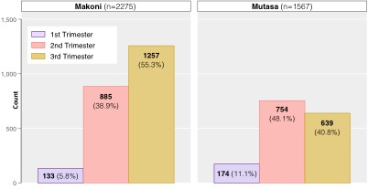

In round 5, 71% of facilities interviewed in Makoni and 53% of facilities in Mutasa provided ARV treatment for infants at 6 weeks. In round 6, these proportions increased to 100% in Makoni and 95% in Mutasa.

Table 5: Number of babies and mothers who received ART

 | Makoni |  | Mutasa
 | R5 | R6 | R5 | R6
Mothers who received ART for their own health | 36 | 108 | 39 | 54
Mothers received ARV prophylaxis for PMTCT | 107 | 0 | 55 | 0
Babies who received ARV prophylaxis | 235 | 171 | 120 | 133

Service provision for early infant diagnosis (EID) at 6 weeks showed that, there was an increase from 94% to 100% for facilities in Makoni, between round 5 and round 6. There was no change for Mutasa that remained at 95% between round 5 and round 6.

Table 6: Number of infants who were tested and/or received ART
 | Makoni |  | Mutasa
 | R5 | R6 | R5 | R6
Babies screened through Early Infant Diagnosis at 6 weeks | 110 | 56 | 92 | 42
Infants put on ARV treatment at 6 weeks | 62 | 3 | 8 | 5

Provision of Drug Services
Table 7 compares the availability of drugs in clinics and hospitals across both districts between rounds 5 and 6. There has been an increase in the availability of PEP drugs in both districts. The availability of 1st line ART drugs in Makoni district increased from 83% to 100%. 2nd line ART availability decreased slightly from 67% to 65% in the same district.

Table 7: TB & HIV drug availability in hospitals & clinics
 | Makoni |  | Mutasa
 | R5 | R6 | R5 | R6
% with PEP drugs available | 71% | 94% | 58% | 100%
% with TB drugs available | 100% | 100% | 95% | 100%
% with adult CTX available | 88% | 100% | 95% | 94%
% with child CTX available | 65% | 29% | 11% | 50%
% with 1nd line ART drugs available | 83% | 100% | 100% | 100%
% with 2nd line ART drugs available | 67% | 65% | 56% | 83%

None of the facilities experienced a stock out for 1st line ART drugs over the past year except Headlands clinic which reported a stock out for a period of one month at R5.

The number of facilities that provide ARV drugs increased significantly across the two districts as shown in Table 8.

Table 8: Number of facilities that provide ARVs Drugs to Patients
 | Makoni |  | Mutasa
 | R5 | R6 | R5 | R6
Facilities that provide ARV drugs | 6 | 17 | 9 | 18
Facilities that reported a stock-out | 1 | 0 | 0 | 0
Facilities that do not provide ARVs | 11 | 0 | 10 | 1
Total number of facilities in study | 17 | 17 | 19 | 19

Key Results: Other Services

VMMC
The number of individuals who went for VMMC within the most recent 3-month period increased dramatically in Makoni and dropped in Mutasa.

Table 9: Number of VMMCs performed in R5 and R6
 | Makoni | Mutasa | Total
R5 | 17 | 423 | 440
R6 | 308 | 124 | 432

HIV Testing and Counselling
As shown in Table 10, the total number of people who received HTC in the past month increased in both districts since round 5.

Table 10: Number of patients who received HTC services
 | Makoni |  | Mutasa
 | R5 | R6 | R5 | R6
Medical patients all ages (PITC) | 594 | 452 | 295 | 623
Men & non pregnant women (General VCT) | 376 | 520 | 532 | 553
Pregnant women (ANC/PMTCT) | 437 | 539 | 235 | 313
Children 2 -14 yrs (General) | 43 | 144 | 57 | 94
Infants <2 yrs (General) | 31 | 88 | 22 | 29
Total | 1481 | 1743 | 1141 | 1612

The proportion of women who brought their male partners for ANC and HTC remained generally the same for Makoni district and increased from 23% to 30% for Mutasa district.

Table 11: Proportion of women who bring male partners for ANC and HTC
 | Makoni |  | Mutasa
 | R5 | R6 | R5 | R6
Proportion of women who bring Male partners for ANC and HTC | 37% | 36% | 23% | 29%

TB
All participating facilities in round 6 provide TB medication to patients. Though, as shown in Table12, the number of staff who had received training in TB treatment and diagnosis in the last 2 years decreased in both rounds.

Table12: Number of staff trained in TB detection and treatment
 | Regular TB |  | MDR TB management
 | Makoni | Mutasa | Makoni | Mutasa
R5 | 28 | 33 | 8 | 24
R6 | 18 | 17 | 11 | 13

Psychosocial Support for PLHIV
The number of facilities that offer psychosocial support has increased in both Makoni (R5=1, R6=18) and Mutasa (R5=12, R6=19).

Condom Distribution
The number of male and female condoms distributed in Makoni increased (particularly female condoms) but decreased in Mutasa.

Table13: Number of condoms distributed in the last month, R5 and R6
 | Makoni |  | Mutasa
 | R5 | R6 | R5 | R6
Male condoms distributed last month | 15909 | 16056 | 25697 | 15778
Female condoms distributed last month | 919 | 4812 | 1104 | 553

STIs
All facilities interviewed in rounds 6 provide STI follow-up counselling and condoms. All but Africa University Clinic conduct contact tracing. Table14 shows the number of patients who received treatment for STIs in rounds 5 and 6. The number of patients who received treatment for HSV-2 increased for men and women in round 6. In contrast, the number of men and women who received treatment for genital discharge decreased. The number of patients who received treatment for genital ulcers decreased in Makoni but increased slightly in Mutasa for both genders.

Table14: Number of patients who received treatment for STIs
 |  | Makoni |  | Mutasa
 |  | Round 5 | Round 6 | Round 5 | Round 6
HSV-2 | Male | 4 | 11 | 6 | 7
 | Female | 4 | 14 | 10 | 13
Genital Ulcers | Male | 127 | 46 | 23 | 29
 | Female | 99 | 53 | 21 | 28
Genital Discharge | Male | 234 | 66 | 71 | 52
 | Female | 396 | 191 | 127 | 104

Recommendations

MUTASA DISTRICT

HIV PROGRAMMES SERVICES

- More PMTCT campaigns and involvement of community leaders is needed to increase the number of pregnant women booking in the first trimester.
- Increase scale-up of both male and female condom distribution and education on correct and consistent use is needed to reduce STIs.
- VMMC services should be provided on a more consistent basis including through having outreach teams and involvement of community leaders.
- Increase staff training in TB detection and treatment.

RECORD KEEPING AND DATA QUALITY

- Resources should be mobilised so that all ART health centres have computers linked to the ART Electronic Patient Monitoring System (EPMS) in order to track clients and also improve on data quality.
- More training and mentorship for health services providers is needed to ensure that there good quality data.

MAKONI DISTRICT

HIV PROGRAMMES SERVICES

- More PMTCT campaigns are needed in order to increase the number of pregnant women booking in the first trimester given that the majority of pregnant women had their first ANC booking in their third trimester.
- Given that there was an increase in the number of ART patients who were lost to follow-up, there is need to mobilise resources and strengthen the tracking systems of patients so that we ensure good treatment outcomes.
- Steps must be taken to maintain good stocks of child CTX at all clinics.
- Increase staff training in TB detection and treatment.

RECORD KEEPING AND DATA QUALITY

- Resources should be mobilised so that all ART health centres have computers linked to the ART Electronic Patient Monitoring System (EPMS) in order to track clients and also improve on data quality.

